E-Commerce Sales & Customer Analytics: Driving Growth Through Customer Segmentation and Sales Forecasting

Presented by: Ankita
June 12 2026

- Executive Summary
This report presents a comprehensive analysis of e-commerce sales performance, customer behaviour, and future revenue projections. The objective is to provide actionable, data-driven insights to optimize inventory, enhance marketing strategies, and improve customer retention.

Key Findings
- Sales Performance: Technology is the highest revenue-generating category ($836,154) despite having the lowest sales volume, indicating strong pricing power and high unit value. Office Supplies drives sales volume (22,906 units) and emerged as the fastest-growing category, recording approximately 62.14% growth between 2014 and 2017.
- Customer Segmentation: The RFM (Recency, Frequency, Monetary) analysis highlights significant customer retention opportunities. At Risk customers (130) represent the largest actionable segment requiring immediate re-engagement, while Lost customers (126) indicate potential revenue recovery opportunities. High-Value customers (106) remain a key contributor to overall profitability and should be prioritized through loyalty and retention initiatives.
- Forecasting Results: The Holt-Winters Exponential Smoothing model forecasts relatively stable sales over the next six months, with expected seasonal fluctuations but no strong evidence of sustained long-term growth or decline. The model achieved a forecast error of approximately 20.5%, indicating moderate forecasting accuracy.
- Major Business Opportunities: Key growth opportunities include expanding the rapidly growing Office Supplies category, maximizing revenue from the high-value Technology segment, implementing targeted retention campaigns for At Risk customers, and strengthening marketing efforts in high-performing markets such as New York, Los Angeles, and Seattle.

Key Recommendations:
We recommend a comprehensive strategy focusing on inventory optimization aligned with seasonal forecasts, aggressive retention strategies and personalized marketing, targeting at-risk customers and marketing campaigns tailored to high-growth categories and regions.

- Introduction
In today’s competitive e-commerce landscape, relying on intuition is no longer sufficient for
sustainable growth. This report provides a rigorous, data-driven analysis of historical sales data, customer purchasing behaviour, and future demand projections.

Objective: The primary purpose of this analysis is to transform raw transactional
data into strategic business intelligence. The core objectives are to identify the most profitable product categories, understand customer lifecycle dynamics, and forecast future sales to inform operational planning.

Scope of the Project: The scope encompasses three main analytical pillars:

- Sales Performance Analysis: Evaluating revenue and volume trends across product categories and geographical regions over a four-year period (2014-2017).
- Customer Behaviour Analysis: Utilizing RFM segmentation to categorize the customer base and identify retention risks and high-value opportunities.
- Sales Forecasting: Applying time-series forecasting models to predict future sales trends over a six-month horizon.

- Sales Performance Analysis

Monthly and Yearly Sales Trends
Overall sales performance has demonstrated consistent growth over the analysed four-year period, characterized by distinct seasonal patterns. The data indicates strong year-over-year revenue increases, with notable peaks occurring during the fourth quarter, likely driven by holiday shopping and end-of-year promotions.
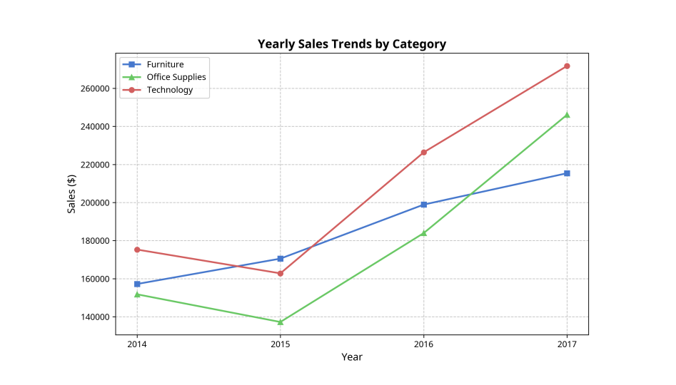
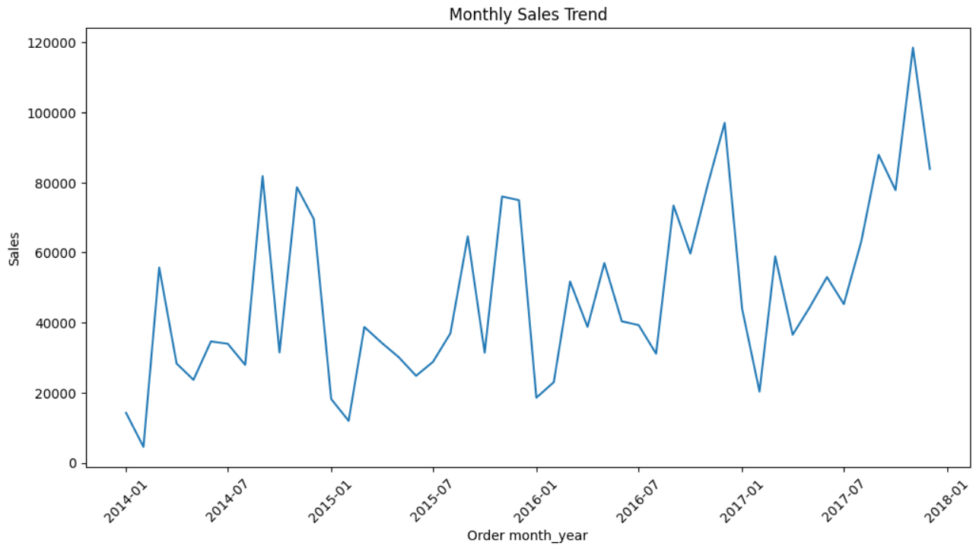

Business Interpretation:
The consistent upward trend validates the current overall business strategy. However, the pronounced seasonal fluctuations necessitate agile inventory management and targeted promotional planning to maximize revenue during peak periods and stimulate demand during slower months.

Category Performance

Category | Revenue ($) | Quantity Sold
Technology | 836,145 | 6936
Furniture | 741,999 | 8028
Office Supplies | 719,047 | 22,906

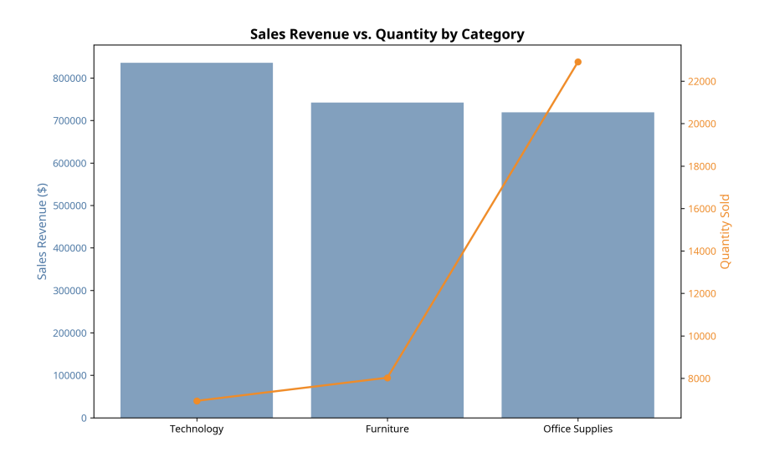
Business Interpretation:
- Technology: This category is the undisputed revenue leader, generating $836,154 despite having the lowest sales volume (6,939 units). This indicates a high average order value and strong profit margins. The business strategy here should focus on premium positioning, upselling, and protecting margins.
- Office Supplies: Conversely, Office Supplies generates strong revenue ($719,047) through significantly higher sales volume (22,906 units). This category relies on high turnover and repeat purchases. Strategies should focus on customer acquisition, bulk discounts, and subscription models to maintain volume.
- Furniture: Furniture maintains a stable, middle-ground performance in both revenue and volume. Given the likely higher shipping and storage costs associated with this category, optimizing logistics and supply chain efficiency is critical for profitability.

High-Growth Category Analysis

Category | 2014-2015 Growth | 2015-2016 Growth | 2016-2017 Growth | Overall Growth (2014-2017)
Office Supplies | -9.58% | 34.03% | 33.79% | 64.14%
Technology | -7.13% | 39.06% | 20.04% | 55.03%
Furniture | 8.48% | 16.65% | 8.29% | 37.02%

Business Interpretation:
- Office Supplies is the fastest-growing category: With a total growth of 62.14% over the period, this category represents a massive opportunity for scaling. The business should allocate more marketing spend to capture market share in this rapidly expanding segment.
- Technology remains the strongest revenue contributor: With 55.03% total growth, Technology continues to be the primary engine for top-line revenue. Continuous product innovation and strategic partnerships are essential to maintain this trajectory.
- Furniture demonstrates steady growth: While slower (37.02%), the growth is consistent. The focus should be on steady, sustainable expansion rather than aggressive, high-risk investments.

Regional Sales Analysis
Geographic performance varies significantly, highlighting the need for localized strategies.

Top Performing Locations:
- New York
- Los Angeles
- Seattle

Low Performing Locations:
- Abilene
- Elyria
- Jupiter

Business Interpretation:
The Concentration of high performance in the major metropolitan areas (New York, Los Angeles, Seattle), suggests strong brand presence and market penetration in urban areas. This presents opportunities for launching premium products and localized marketing. Conversely, we can see weak performance in small markets (Abilene, Elyria, Jupiter), possibly due to: lack of brand awareness, uncompetitive pricing or logistical challenges.

- Customer Behaviour Analysis

RFM Segmentation
To understand customer value and lifecycle stages, an RFM (Recency, Frequency, Monetary) analysis was conducted. This methodology segments customers based on how recently they purchased, how often they purchase and how much they spend. This is critical for moving away from a “one-size-fits-all” marketing approach to a highly targeted and personalized engagement.
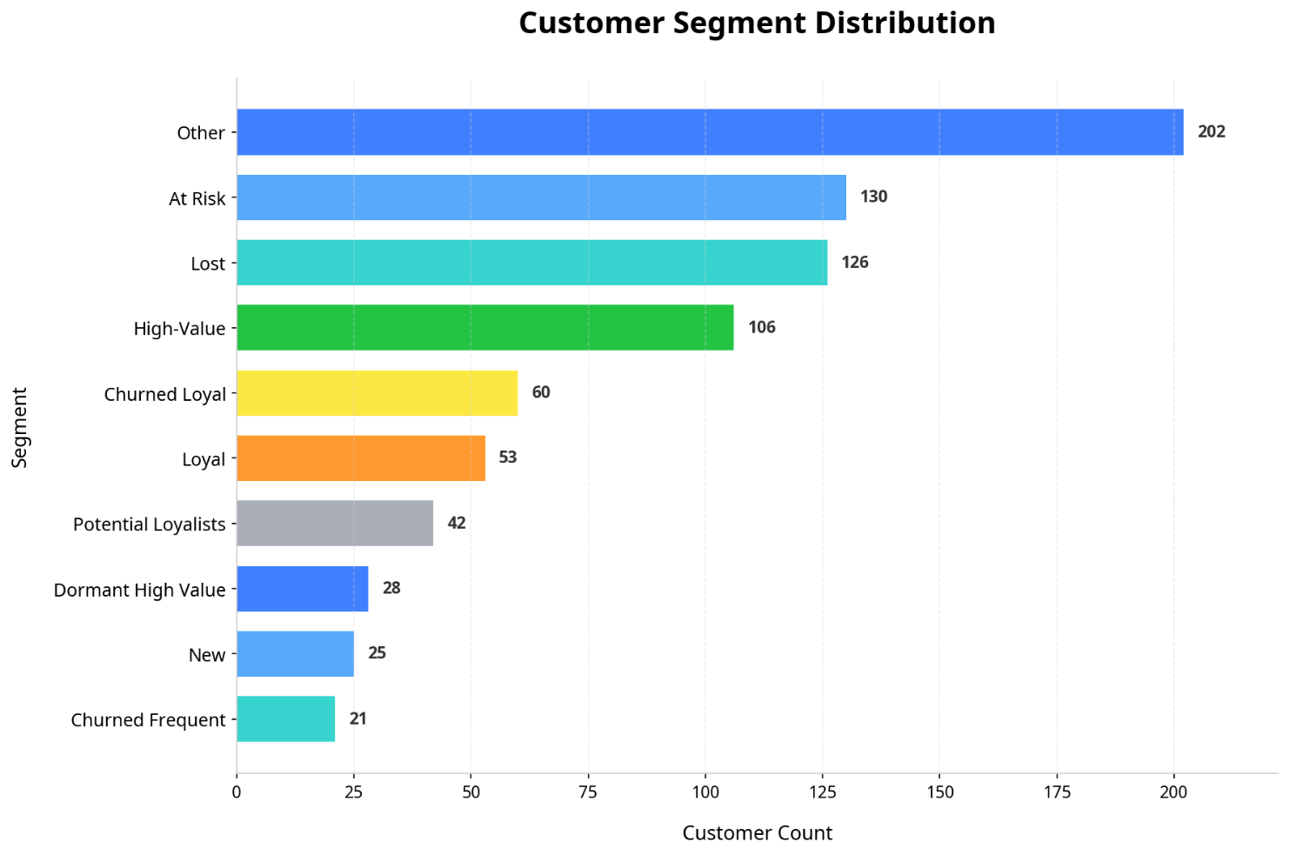
Segment Distribution:
High-Value Customers (106)
These customers purchase frequently, spend more, and have purchased recently. They represent the most valuable customer segment.

Loyal Customers (53)
These customers regularly engage with the business and contribute stable revenue.

Potential Loyalists (42)
These customers show promising purchasing behaviour and can be converted into loyal customers through targeted engagement.

New Customers (25)
Recently acquired customers who require nurturing to increase purchase frequency and spending.

At Risk Customers (130)
Customers who previously engaged with the business but have reduced recent activity. This segment represents a significant retention opportunity.

Lost Customers (126)
Customers who have not purchased recently and may require win-back campaigns.

Churned Loyal Customers (60)
Previously valuable customers who have stopped engaging with the business. Recovering even a portion of this segment could generate substantial revenue.

Dormant High Value Customers (28)
Customers with historically high spending but low recent engagement.

Churned Frequent Customers (21)
Customers who purchased often in the past but have become inactive.

Business Interpretation:
More than 300 customers belong to At Risk, Lost, Churned Loyal, Dormant High Value, and Churned Frequent segments combined, indicating a historical issue with long-term retention. However, the presence of 106 “High-Value” customers demonstrates that when retention is successful, it is highly profitable.

- Forecasting Insights

Forecasting Methodology
To project future revenue, Holt-Winters Exponential Smoothing model was employed. The model was selected because historical data exhibited both a clear trend and distinct seasonal pattern. The model uses monthly sales data to capture these dynamics accurately.

Train-Test Split
- Training Data: 36 months
- Testing Data: 12 months
The model was trained and tested on historical sales data to ensure the model can generalize to future, unseen data.

Model Performance
The model’s performance during the testing period was evaluated using Root Mean Square Error (RMSE).
- RMSE: 12,540.9
- Average Test Period Sales: 61,101.27
- Forecast Error: Approximately 20.5%

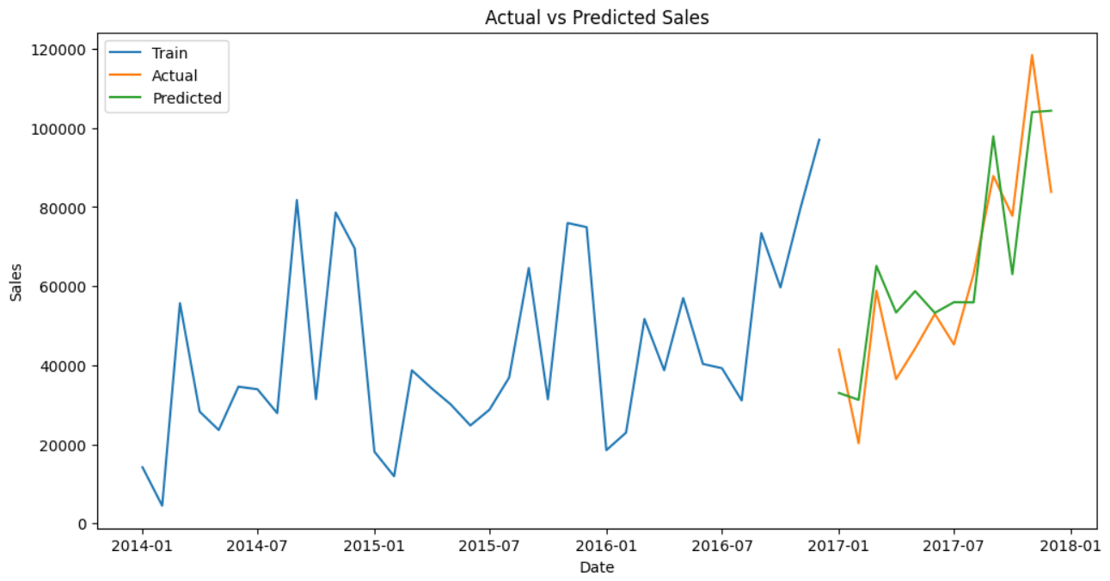

Business Interpretation:
The model achieved moderate forecasting accuracy and successfully captured overall sales trends and seasonal patterns. However, it was less effective at predicting sudden sales spikes.

Future Sales Forecast
Based on the validated model, a 6-month forecast was generated.

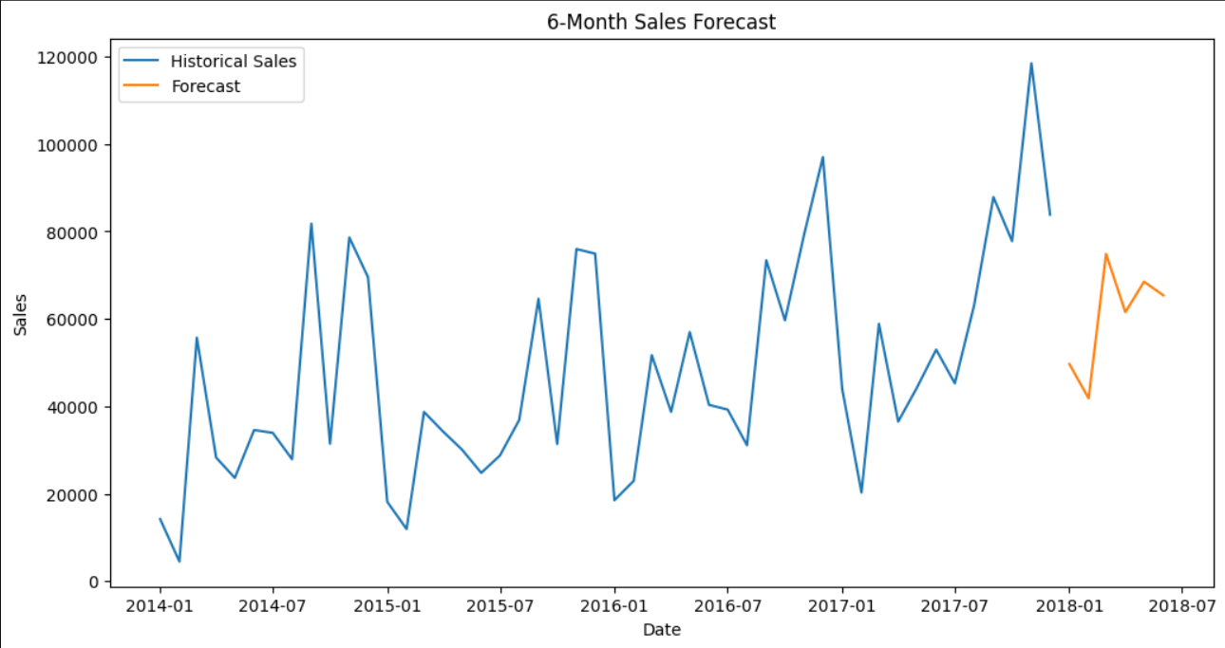

Business Interpretation:
- Forecasted sales are expected to remain relatively stable.
- Moderate seasonal fluctuations are expected.
- No strong long-term growth or decline trend is visible.

Business Implications
- Inventory Planning: Stable forecast allows for an optimized inventory management. It should be aligned with the predicted moderate fluctuations to minimize holding costs while preventing stockouts.
- Revenue Planning: Keeping in mind the stable forecast, financial projections should be conservative rather than anticipating aggressive growth.
- Marketing Implications: Since organic, explosive growth is not forecasted, achieving revenue targets above the baseline will require proactive, aggressive marketing campaigns and the successful execution of the retention strategies outlined in Section 4.

- Business Opportunities

Opportunity 1: Expand Office Supplies
Office Supplies demonstrated the highest growth rate (62.14%) and sales volume. This represents a massive opportunity to capture market share.

Opportunity 2: Maximize Technology Revenue
Technology generates the highest revenue with the lowest volume, indicating premium pricing and strong margins. The strategic imperative here is margin protection and average order value (AOV) expansion by upselling.

Opportunity 3: Improve Customer Retention
The RFM analysis revealed a critical vulnerability: a large segment of “Lost” and “At-Risk” customers. “Dormant High Value” and “Churned Loyal” segments also need focus in order to win back valuable customers.

Opportunity 4: Strengthen High-Performing Markets
The concentration of sales in major urban areas demonstrates a strong product market fit in those regions. The business should double down on these areas with localized and impactful marketing campaigns.

Opportunity 5: Leverage Seasonal Demand
The forecasting model confirms the presence of strong seasonal patterns. By aligning inventory management, marketing spend and promotional calendars in advance of predicted peaks, revenue can be maximize during high demand periods.

- Recommendations & Action Plan

Strategic Area | Recommendation | Expected Business Impact | Implementation Approach
Inventory Optimization | Align procurement with the 6-month forecast. | Reduced holding costs by 10-15%; minimized stockouts during seasonal peaks | Pre-order high-volume Office Supplies ahead of seasonal trends.
Marketing Strategy | Launch targeted campaigns for Office Supplies and Technology. | Increased market share in Office Supplies and a higher Average Order Value (AOV) in Technology. | Implement Cross selling and bulk-purchase programs B2B Office Supplies sales. Create premium bundle offers (e.g., Laptop + Accessories) for Technology.
Customer Retention | Deploy a “Win-Back” Campaign for At-Risk, Churned Loyal and Dormant High Value Customers. | Improved revenue as well as overall Customer Lifetime Value (CLV). | Utilize email marketing automation to send personalized discount codes or “We Miss You” offers.
Pricing and Promotion | Implement dynamic pricing in high-performing regions. | Optimized profit margins in strong markets. | Begin with testing slight price premium on high-demand Technology items in the top-tier-cities; offer discounts on bulk-orders of Office Supplies in lower-performing regions to stimulate demand.
Regional Expansion | Find the barriers in low-performing markets. | Identification of failures preventing regional growth. | Conduct localized customer surveys, analyse competitor pricing and shipping time in the low-performing locations.
Forecast Monitoring | Monthly Review of the forecast and measure the deviation from actual sales. | Ability to pivot inventory and plans immediately if actuals deviate from the predictions. | Schedule mandatory monthly review meetings to compare the actual sales against the predicted sales.

- Conclusion
This analysis highlights the business has a strong foundation in revenue generation, primarily driven by high-margin Technology sales and rapidly growing volume in Office Supplies. The historical data demonstrates a consistent yearly growth and predictable seasonal patterns, which our forecasting models indicate, will continue in a stable manner in the next six months.

However, significant business risk and also the greatest opportunity lies in customer retention. The RFM segmentation clearly shows a large number of customers falling in the “Lost” and “At-Risk” segment.

By shifting focus toward data-driven customer retention initiatives, optimizing inventory based on the forecasts and aggressively scaling the high-growth Office Supplies category, the organization will not only maintain its current stability but also drive significant profitable growth in the coming year. Success will depend on the disciplined execution of the recommended action plan and a continued utilization of analytics for strategic decision-making.

